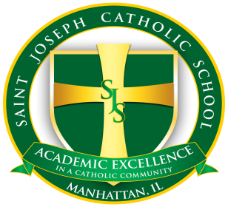
St. Joseph School
275 W. North Street
Manhattan IL, 60442
www.sjsmanhattan.org

2024-2025 Kindergarten Schedule Options

The following are the schedules for the Kindergarten program at St. Joseph Catholic School. Please note the two options for our Kindergarten program and indicate your preference below.

Half day (8:30 a.m. to 11:40 a.m.)
Full day (8:30 a.m. to 3:00 p.m.)

Family Name: ____________________________ Date:__________________
Address:_________________________________ Phone (home)_____________
Email:___________________________________ Phone (cell)____________
Child’s Name: ____________________________

I would like to confirm my 2024-2025 registration for the half day Kindergarten
program.

I would like to confirm my 2024-2025 registration for the full day Kindergarten
program.

